**Name: _______________________________________**

**Python Activity 14: Reading from Files**

|  |
| --- |
| **Learning Objectives**  Students will be able to:  *Content:*   * Explain how to open a text file for reading * Explain the difference between the read() and readline() functions * Explain the purpose of the **str() function.** * Explain the effect of the arguments of the range function when reading data from a file. * Explain the purpose of the **rstrip(), open(), and close() functions**   *Process:*   * Write code that opens, writes to and closes a file * Write code that opens, reads from and closes a file * Write code that uses a nested FOR loop   **Prior Knowledge**   * Python concepts from Activities 1-12 |

**Critical Thinking Questions:**

|  |
| --- |
| **FYI:** In Python, you can access data from a text file as well as from the keyboard. You can create a text file in any text editing tool. You should only have one data item per line in the file. |

1. Create a text file named **sports.txt** and enter the sports listed below, one word per line.

Enter and execute the program. Be sure the saved program is in the same folder as the text file.

|  |  |
| --- | --- |
| **Python Program** | **sports.txt file** |

* 1. What does the program do? It prints the content of sports.txt
  2. In the first line of code, what does the ‘string argument’ for the function **open** represent?

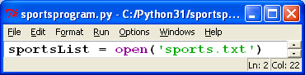

It is the file that python needs to look for

* 1. Replace the call to the **function *read()*** with the function ***readline().*** Execute the program again. Explain the difference between the two functions: **read()**  and **readline().**

Read line is just a singular line. Read is the whole file.

2. Enter and execute the following code.

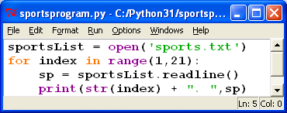

a. How does the output from this program differ from the output of the program that used the “read()” function? What caused the difference?

If read() was used instead of readline() It would print the entire file every time the loop executes instead of one line at a time

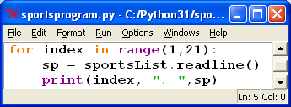 b. What is the subtle difference in the output if the following print statement replaced the one above? Which is better?

It adds a space between the index and the period.

c. What does **str(index)** do in the program above? Why is the **str** () function necessary?

Its required to turn the int value of the index to str

d. What happens when you change the arguments in the **range()** function to **1,10?**

It only prints 9 lines

e. What happens when you change the arguments in the **range()** function to **(0, 30)**?

After line 20 it prints nothing because these liunes are blank

f. What do the results from “d.” and “e.” tell you about the arguments of the **range()**  function when you are reading data from a file with a *for* loop?

That the range will always run weather there range is less then the line total or greater.,.

|  |
| --- |
| **FYI:** The purpose of the **rstrip()** function returns a copy of the string after all characters have been stripped from the end of the string (default whitespace characters, EOL characters, and newline characters). |

3. The following program is slightly different from the program in #2. Enter and execute the program.

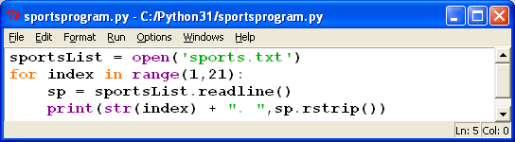

1. Compare the output from this program to the previous program. What is the difference?

There isn’t an blank line between each item on the list

1. What code caused the difference in the output?

Sp.rstrip()

1. Does the **rstrip()** function contain any arguments? How does it know what string to act upon?

Sp is a variable that indicates the str that needed to be used.

d. **lstrip()** is a similar function. What do you think it does?

It strips the characters from the left instead of the right.

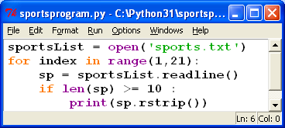4. The following program is slightly different from the program in #3. Enter and execute the program.

a. What does the program display?

It prints items off the last that are 10 or more characters

b. How many functions are used in this program?

6

c. Two functions use what is known as **dot(.) notation.** What are the two functions**?**

Readline() and rstrip()

d. Examine the output and explain what the **len()**  function does.

It is a character limiter.

**Application Questions: Use the Python Interpreter to check your work**

1. Create a text file that contains 10 numbers between 50 and 100. Write a program that reads the numbers from the file and totals the numbers. The program should print all the numbers and display the total when all the numbers have been added together. (Warning! The input from the file will be considered a string. Be sure to convert the input to **int** or **float** – just as you do when numbers are entered from the keyboard.)

numFile=open("nums.txt",'r')

summ=0

lines=numFile.readline().rstrip()

while lines !="":

nums=int(lines)

print(nums)

summ+=nums

lines = numFile.readline().rstrip()

print("And the sum is:", summ)

numFile.close()

#Thanks Tiago for the help

1. Rewrite the following program to allow the user to enter the name of the file. Use the input to open the file.

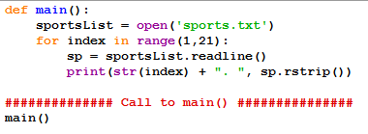

def main():

userFile = open(input("Enter the name of your File: "))

for index in range(1,21)

sp = userFile.readline()

print(str(index) + ". ", sp.rstrip())

main